BANKNOTES RECONITION SYSTEM

Natchanon Sayasonti 5988116

Wannaporn Vichaisri 5988266

**Introduction**

Prior to the adoption of banknotes and flat coins, Thailand used the shell, Baked Clay Coins, and Pot Duang as the money. The first Thai banknote is used since 1912. King Rama 5 had the policy to establish the banknotes. It leads to a growing economic system. People at that time can exchange the product and banknote as obviously.  Thai banknotes are made from cotton fiber, not plastic. The reason why we aim to classify Thai banknote is helping an unknown person such as a foreigner. This tool can help them to classify in a few times.

This project focused on Thai Banknotes which used in King Rama 9, and 10. There are 5 focused types of banknotes which are 20, 50, 100, 500, and 1000. These banknotes have many styles. Therefore, this project will not use all style.

Consequently, the goal of this project is to classify Thai banknotes which one is 20, 50, 100, 500, and 1000 correctly by using a digital image processing method.

**Methodology**

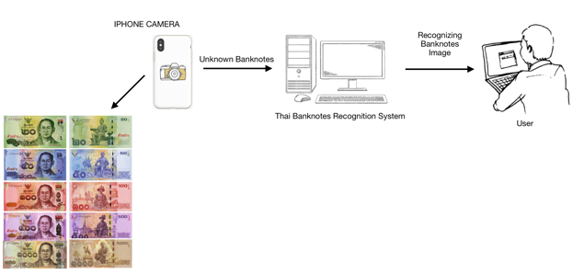

Figure 1: Conceptual Diagram

**Structure Chart**

Thai banknote recognition system consists of five main process modules:

1) image acquisition

2) image preprocessing

3) feature extraction

4) image recognition

5) result presentation

**Image acquisition**

The whole data which are images should be taken from bird-eye-views as input in this system. The banknotes have to set the same environment. While taking a picture, the mobile has to available a flashlight mode. All of the banknotes, which are a dataset, have to place in a horizontal line.

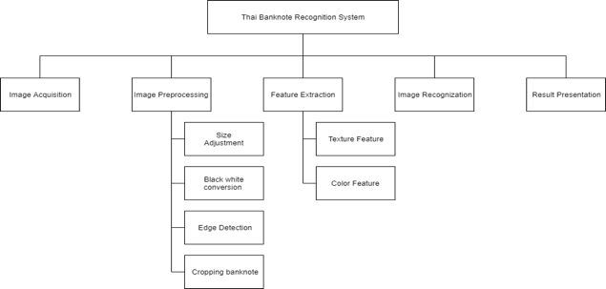

Figure 2: Structure Chart

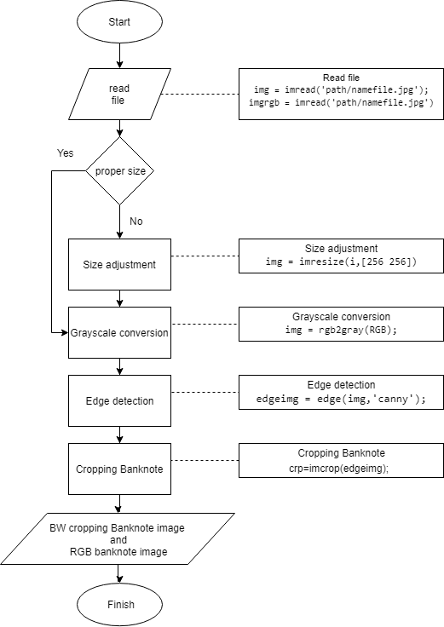

Figure 3: Image Preprocessing Chart

1. Size adjustment

After reading two files, if the picture is an incorrect size in case of images come from different devices, the picture will step in size adjustment process. This process will resize two photos to be the same size.

2. Grayscale conversion

Make one photo to be grayscale for using in texture feature. For the RGB picture, there's no need to step in this process because it will use in the color feature process.

3. Edge detection

After grayscale conversion, the next process is edge detection by using a candy filter because it is suitable for Sobel detection.

4. Cropping Banknote

The unwanted part of the image will be removed by this process. It will be left only the bank. Then the picture is ready to use in the image recognition process.

**Feature extraction**

There are two features that were used in the Thai Banknote Recognition System:

1. Texture feature

2. Color feature

The system will keep the mean color of each color into the excel file

**Image Recognition**

After preparing an excel file, there will be an image recognition method. The technique which this system used to compare two images is Euclidean distance. This is owing to a Euclidean distance formula can be used to calculate the distance between two data points in a plane. If the value is very few, it meant that two datasets are very similar as well. The equation is below in figure 4.

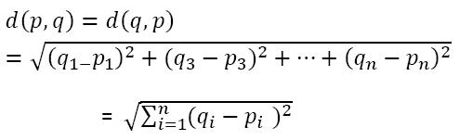

Figure 4:  Euclidean distance equation

**Result Presentation**

There will be 2 axes charts which are upload pictures and result in pictures. The edit bar which below those charts represents the name of the file. There are also 3 buttons which are the upload button, the train button, and the recognition button (test). As shown in figure 5.

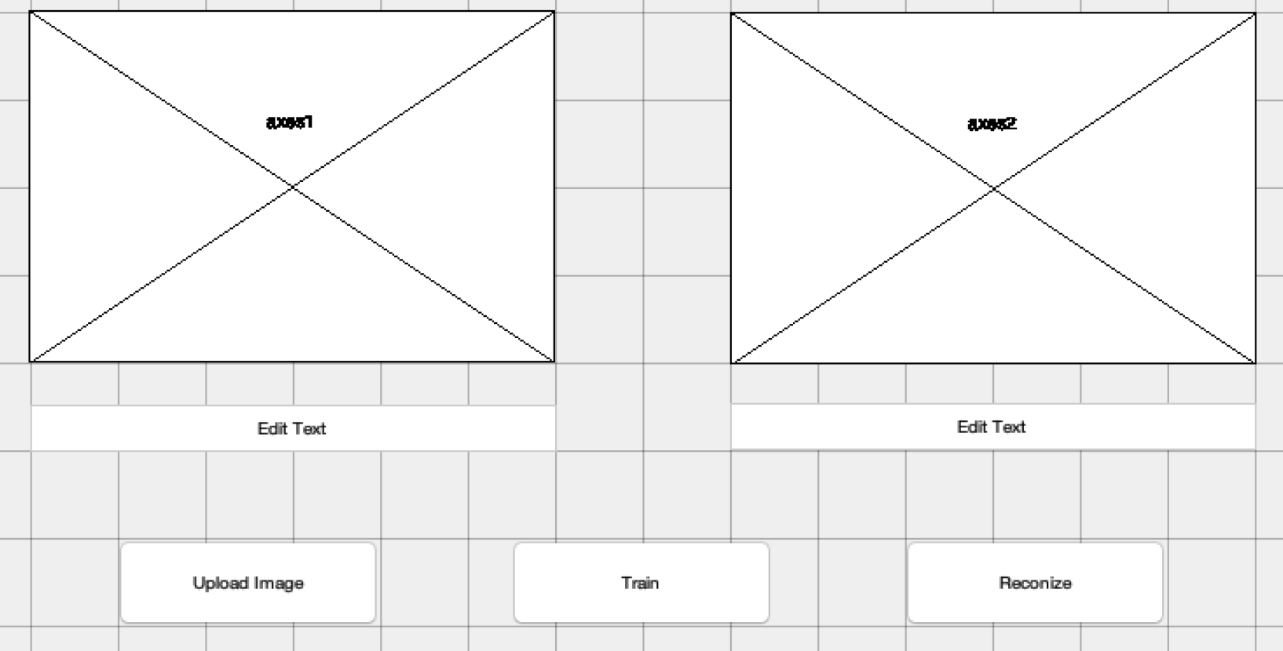

Figure 5: MATLAB result interface

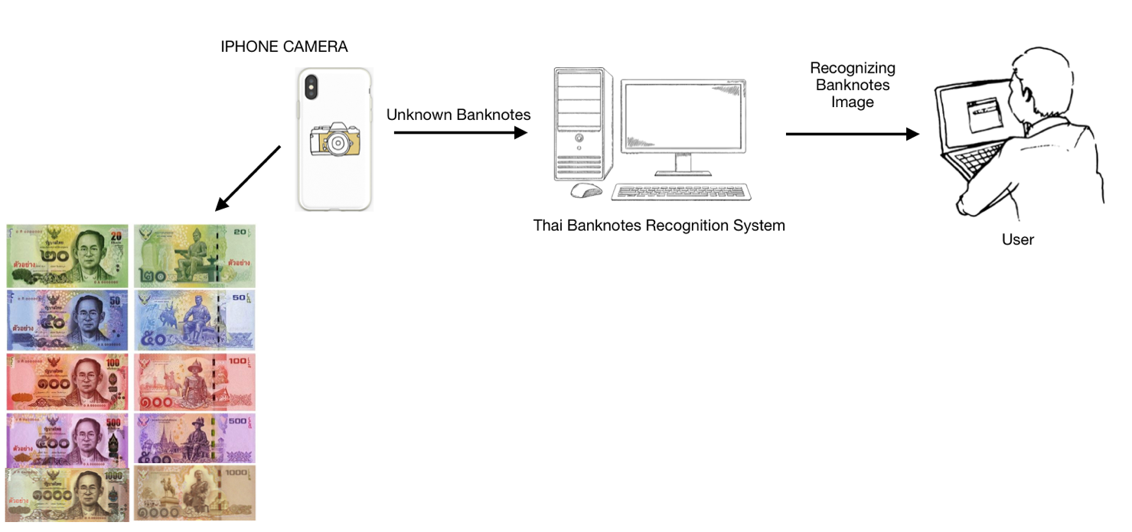

Figure 1: Conceptual Diagram

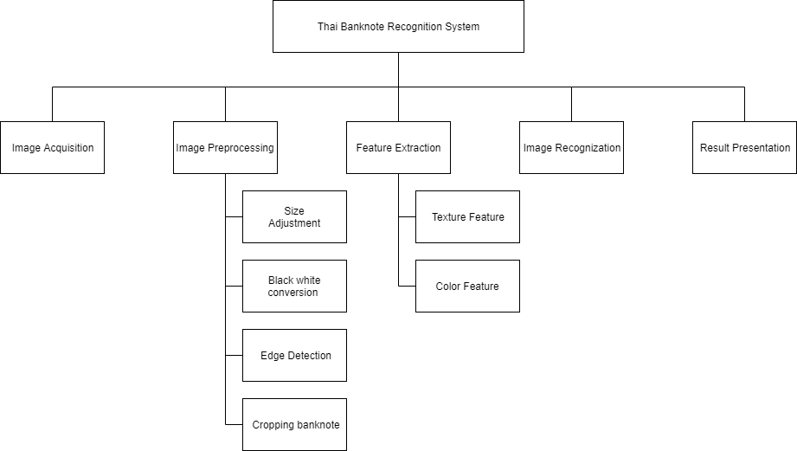

Figure 2: Structure Chart



Figure 3: Image Preprocessing Chart